-- Load data: copy from staging -> dw.raw_* (if staging already has rows
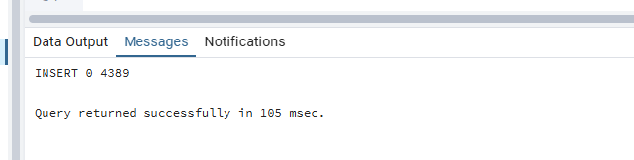
-- same goes with the other tables as well. Data loaded from staging tables successfully

-- Quick counts to confirm raw load (optional debug)
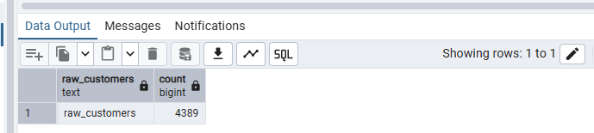

-- Show some sample rows from each DW table
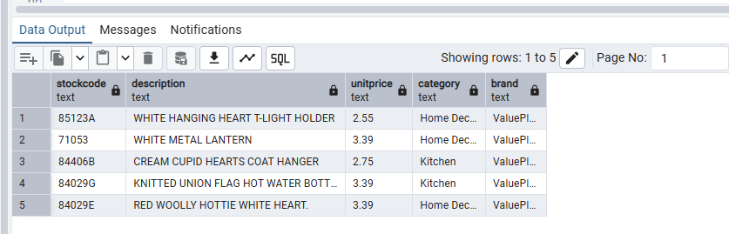
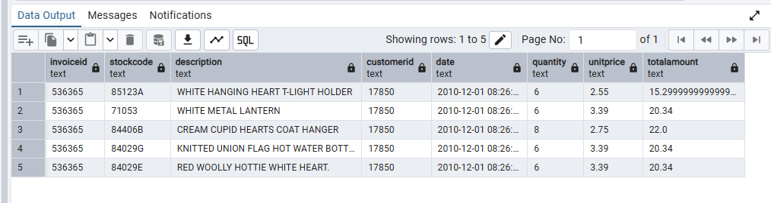
-- PART D: VALIDATION / COMPARISON (ETL vs ELT)
-- - Show counts and sums for fact_sales (ETL) vs fact_sales_elt (ELT) Total 10 comparisons
